**CDAC Mumbai PG-DAC AUGUST 24**

**Assignment No- 2**

1)Write a program that checks if a given year is a leap year or not using both if-else and switch-case.

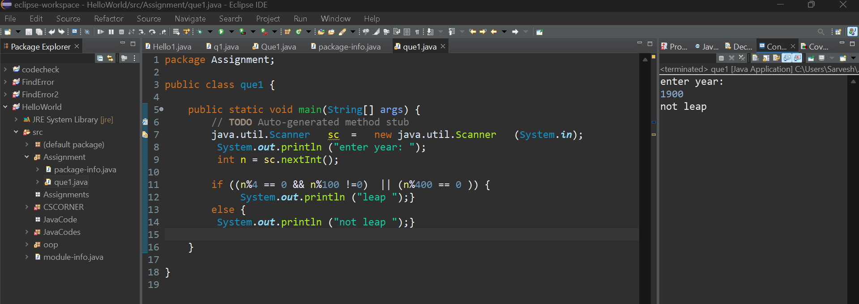

2)Implement a program that calculates the Body Mass Index (BMI) based on height and weight input using if-else to classify the BMI int categories (underweight, normal weight, overweight,etc).

3)Write a program that checks if a person is eligible to vote based on their age.

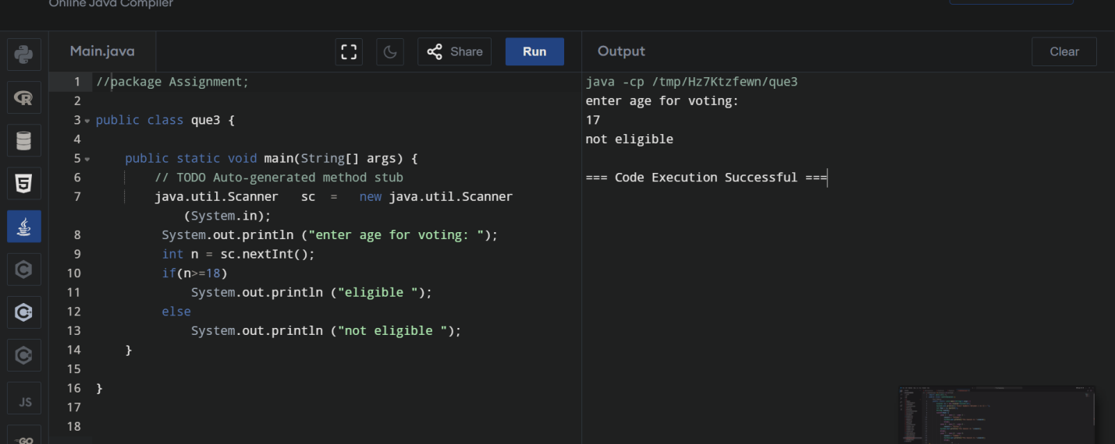

1. Write a program that takes a month (1-12) and prints the corresponding season (Winter, Spring, Summer, Autumn) using a switch case

